# System Design Document (SDD) – Outbound PCSE

## Table of Contents

1 GENERAL INFORMATION

1.1 Executive Summary

1.2 Scope

1.2.1 In-Scope

1.2.2 Out-of-Scope

1.3 Document Usage

1.4 Diagram

1.4.1 DataFlowDiagram

1.4.2 UseCaseDiagram

1.5 Specification Sheet

2 TECHNICAL DESIGN

2.1 Input for Claim Details

2.1.1 Input JSON Structure

2.1.2 Input Request Details

2.1.3 Input - Request Validation

2.2 Output for Claim Details

2.2.1 Output JSON Structure

2.2.2 Output Response Header

2.2.3 Output Response Medical Line

3 BUSINESS RULES

3.1 Claim Filtering Logic (Prime-Pended Claims)

3.2 Error Handling & Logging

4 REFERENCE

5 AMENDMENT HISTORY

# 1 GENERAL INFORMATION

## 1.1 Executive Summary

This document defines the design for Outbound PCSE: Processing claims from Azure Storage Queue messages, fetching Blob JSON, filtering prime-pended claims, transforming, and writing to Snowflake via Member API.

## 1.2 Scope

### 1.2.1 In-Scope

• Reading messages from Azure Storage Queue  
• Fetching claim JSON from Blob Storage  
• Filtering Prime-Pended claims  
• Data transformation  
• Calling Member API  
• Inserting records into Snowflake  
• Error handling with error table  
• Trace logging for processed claims

### 1.2.2 Out-of-Scope

• UI components  
• Manual claim processing  
• Downstream systems outside Snowflake

## 1.3 Document Usage

|  |  |
| --- | --- |
| User Type | Description of Usage |
| Business Analyst | Section 1 |
| Architect | Section 2 |
| Developer | Section 2, 3 & 4 |
| Tester | Section 5 |

## 1.4 Diagram

### 1.4.1 DataFlowDiagram

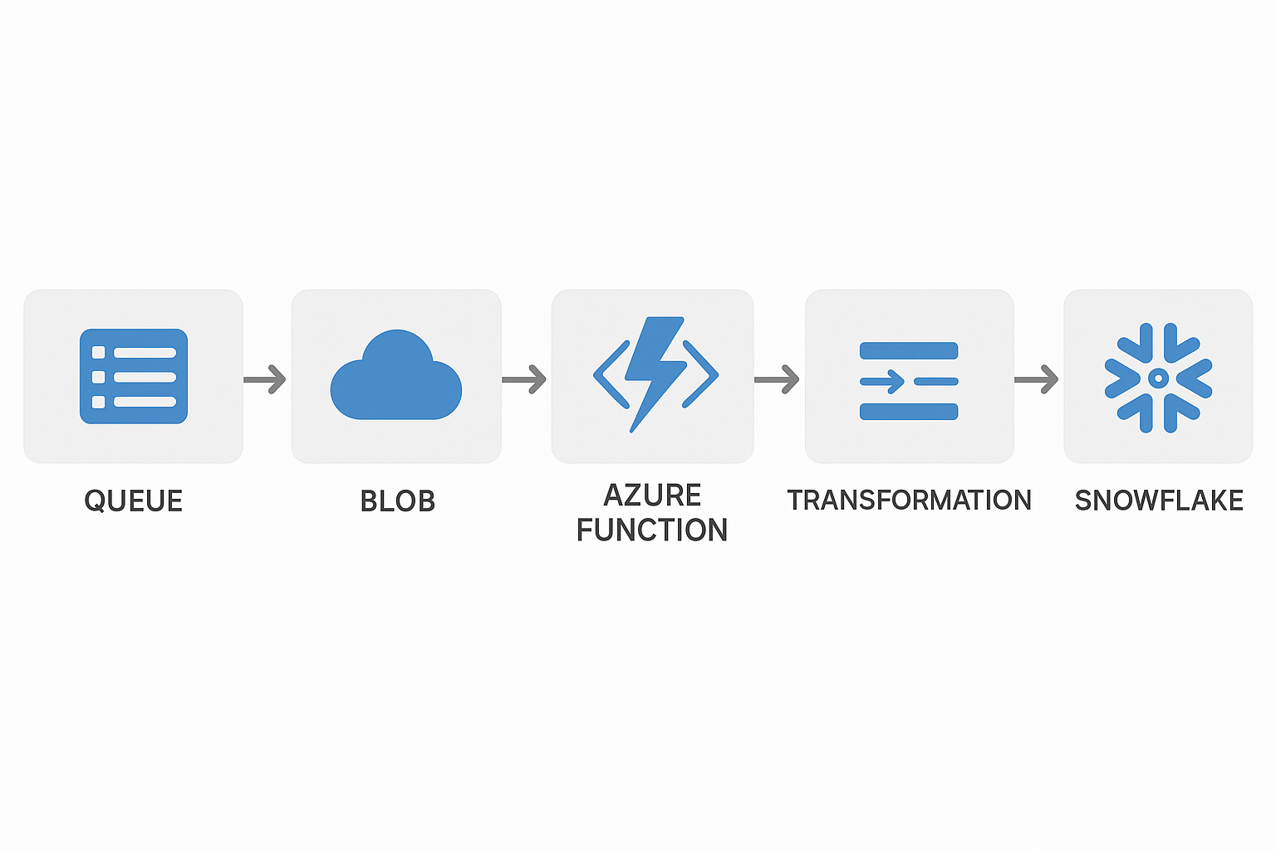

### 1.4.2 UseCaseDiagram

[Placeholder for Use Case Diagram: Actor = Queue/Event, System = Function, API, DB]

## 1.5 Specification Sheet

• Azure Function: Queue Trigger  
• Blob Storage: JSON source  
• API: Member API endpoint  
• Database: Snowflake with Claim Table & Error Table

# 2 TECHNICAL DESIGN

## 2.1 Input for Claim Details

### 2.1.1 Input JSON Structure

{ 'claimId': '', 'status': '', 'memberId': '', ... }

### 2.1.2 Input Request Details

Queue message contains Blob URL. Function retrieves Blob and parses claim JSON.

### 2.1.3 Input - Request Validation

Validation includes schema check, required fields, and Blob access errors.

## 2.2 Output for Claim Details

### 2.2.1 Output JSON Structure

{ 'claimId': '', 'transformedData': {}, 'status': 'Processed' }

### 2.2.2 Output Response Header

API response headers include requestId, timestamp, and success/failure codes.

### 2.2.3 Output Response Medical Line

{ 'claimId': '', 'lineItems': [{ 'serviceCode': '', 'amount': '' }] }

# 3 BUSINESS RULES

## 3.1 Claim Filtering Logic (Prime-Pended Claims)

Claims with status 'Prime-Pended' are filtered and passed for transformation. Others ignored.

## 3.2 Error Handling & Logging

Errors are logged in an Error Table with claimId, errorCode, errorMessage, timestamp.  
Trace logs stored for each processed claim.

# 4 REFERENCE

Azure Functions Documentation, Snowflake Integration Guide, Member API Specs.

# 5 AMENDMENT HISTORY

Version 1.0 - Initial Draft for Outbound PCSE SDD